Break-In Lab Writeup
Gurumanie Singh Dhiman
VM IP Address (IPv4): 190.100.60.238/24

Executive Summary
For this Break-In Lab, I conducted a penetration test against the 532Corp network for the IP range 82.46.91.0/24. After doing so, I uncovered multiple critical and high-severity vulnerabilities across nine machines, including unencrypted Telnet services with weak credentials, SQL injection vulnerabilities on web login pages, DNS zone transfer misconfiguration exposing internal network topology, anonymous LDAP access, password reuse across systems, a backdoor account with unrestricted sudo access, and an unencrypted MySQL database containing sensitive employee PII. I was able to gain successful access to multiple machines using credential brute-forcing techniques from OSINT reconnaissance of the 532Corp public-facing website.
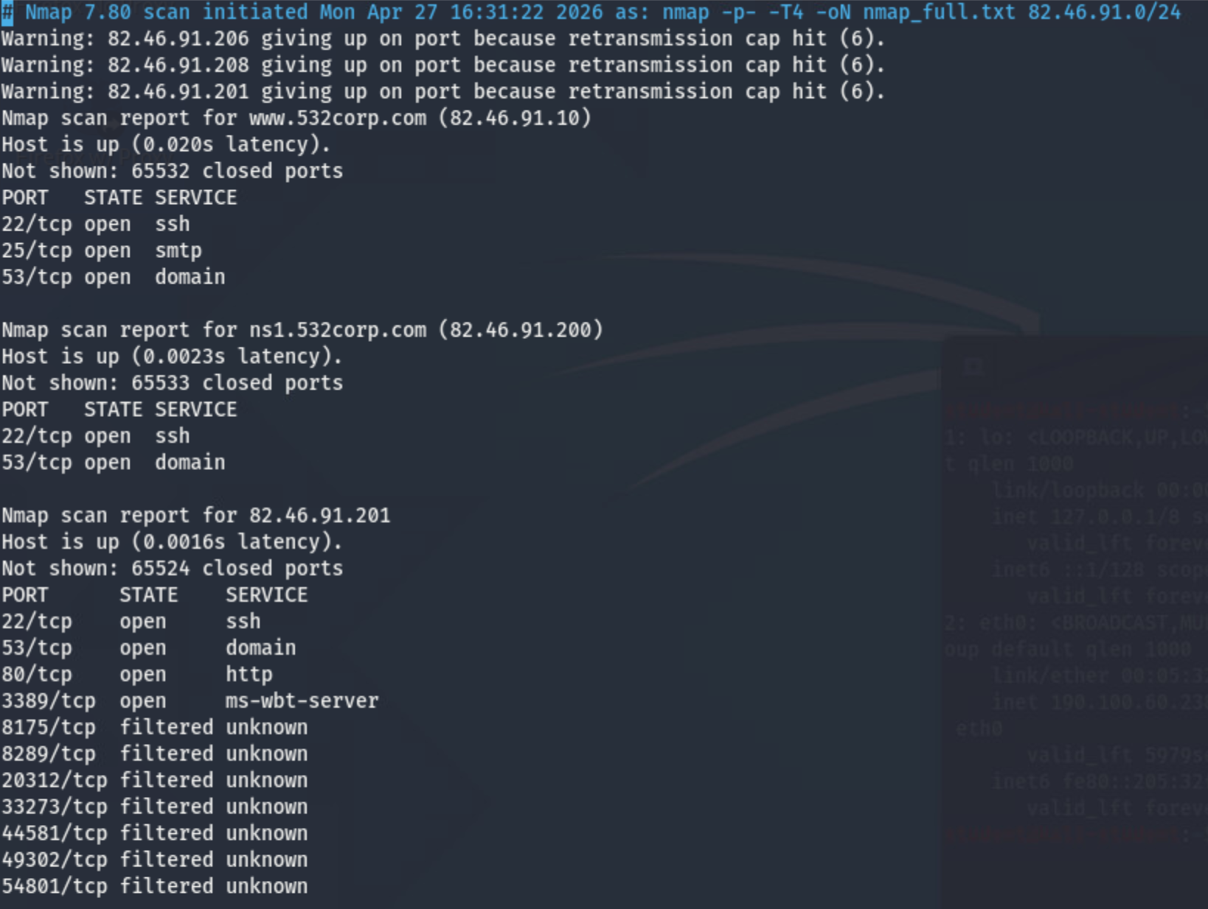
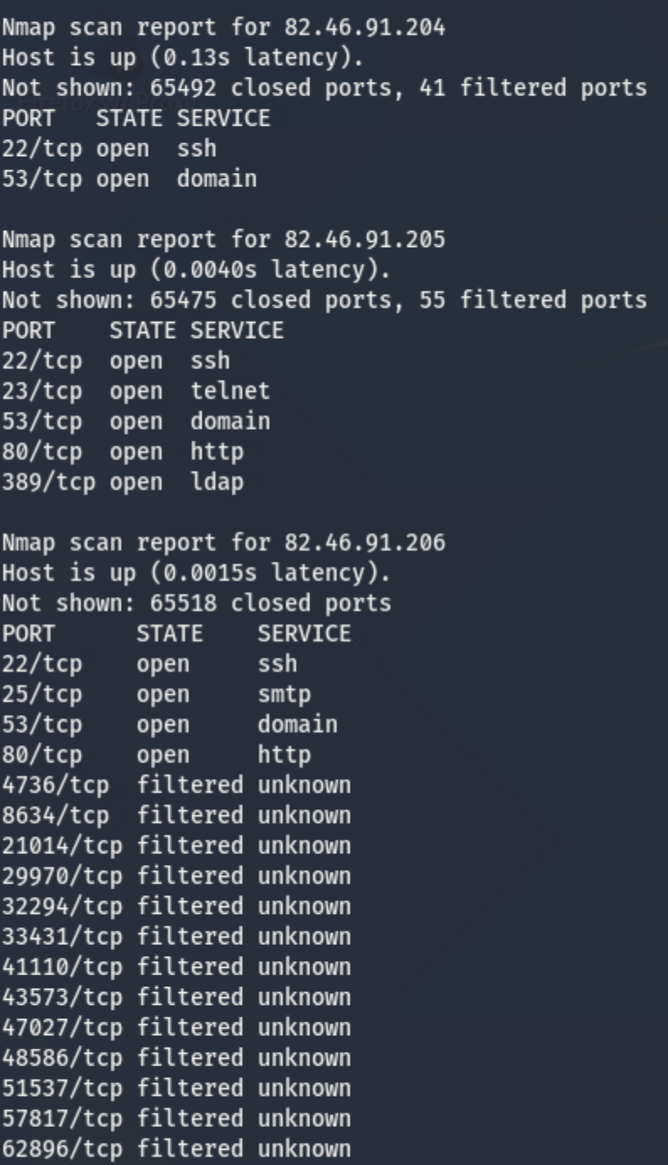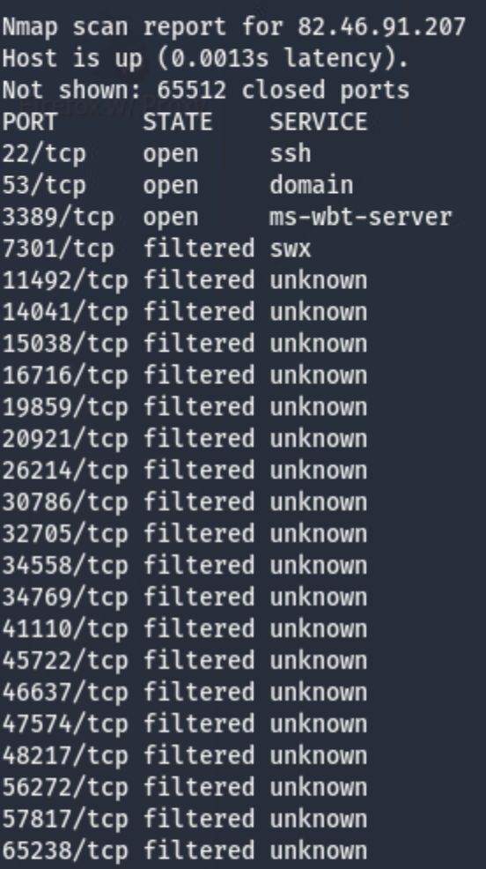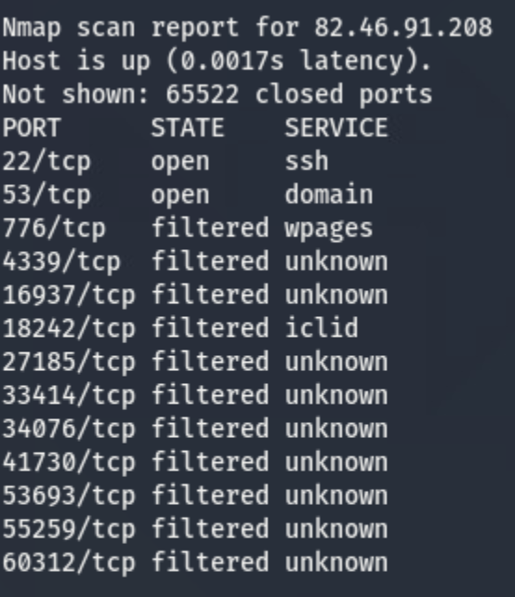

Issues Identified
Host | Vulnerability | Severity | Finding
82.46.91.10 | SMTP unauthenticated internal mail delivery | Medium | Internal mail sent as root without authentication
82.46.91.200 | Password reuse — jsmithison:momo | High | SSH access gained; shadow hash file exposed
82.46.91.201 | SQL Injection on /login.php | Critical | Bypassed auth with OR '1'='1 payload
82.46.91.204 | Weak credentials; backdoor account with root sudo | Critical | jsmithison:momo; su backdoor -> sudo su = root
82.46.91.205 | Telnet enabled; weak credentials; anonymous LDAP; empty Apache dir listing | Critical | tlee:liluzivert via Telnet; LDAP anonymous bind; /lam/ exposed
82.46.91.206 | SQL Injection on /login.php; unencrypted MySQL PII | Critical | Auth bypass; employee SSNs and credit card data accessible
82.46.91.207 | xrdp exposed; XSS web application | High | RDP service accessible; Node.js XSS app running internally
82.46.91.208 | DNS Zone Transfer allowed | High | Full internal network topology exposed

Attack Narrative

Phase 1: Reconnaissance

Network Scanning
An Nmap scan was performed against the full IP range to discover live hosts and open ports:
nmap -p- -T4 -oN nmap_full.txt 82.46.91.0/24
The following hosts were discovered:
- 82.46.91.10 — www.532corp.com (SSH 22, SMTP 25, DNS 53)
- 82.46.91.200 — ns1.532corp.com (SSH 22, DNS 53)
- 82.46.91.201 — Desktop (SSH 22, DNS 53, HTTP 80, RDP 3389)
- 82.46.91.204 — ns2 (SSH 22, DNS 53)
- 82.46.91.205 — LDAP Server (SSH 22, Telnet 23, DNS 53, HTTP 80, LDAP 389)
- 82.46.91.206 — WWWX Server (SSH 22, SMTP 25, DNS 53, HTTP 80)
- 82.46.91.207 — Workstation/www2 (SSH 22, DNS 53, RDP 3389)
- 82.46.91.208 — Mail Server (SSH 22, DNS 53)

Website Reconnaissance for 532corp.hackerville.org
I browsed the 532Corp public website and noted some key points. It is powered by WordPress and lists eight employees with personal biographies. The following employee information and interests were documented for use in password generation:
Username | Full Name | Title | Key Interest / Hint | Password Found
jsmithison | Jennifer Smithison | CEO | Dog named Momo | momo
jgreene | John Greene | CTO | World of Warcraft | —
sdash | Stacy Dash | CIO | French, yoga | —
rjohnson | Robert Johnson | CFO | Go Rameses (UNC) | —
mjones | Mark Jones | Lead PM | Boilermakers, Sigma Phi | —
lpeterson | Lily Peterson | Head of HR | Kayaking | —
scooling | Shane Cooling | Project Manager | Chacos, vegan, BYU | —
tlee | Tommy Lee | Marketing Manager | Drake, Lil Uzi Vert | liluzivert

Finding: WordPress technology identified on 532corp.hackerville.org. Employee biographies contain personal details that directly reveal user passwords which was a significant OSINT risk.

Phase 2: Host Analysis and Exploitation

82.46.91.10 — WWW Server (www.532corp.com)
Ports open: 22 (OpenSSH 8.2p1), 25 (SMTP Postfix), 53 (ISC BIND)
SMTP Enumeration — Metasploit auxiliary/scanner/smtp/smtp_enum identified valid users on the SMTP server with command:
use auxiliary/scanner/smtp/smtp_enum
set RHOSTS 82.46.91.10
run
- Valid users found: scooling, tlee, root
- Domain: www
Finding #1: Internal mail delivery works with no authentication required. Successfully sent email as root to user scooling using MAIL FROM: root@www / RCPT TO: scooling.
DNS Zone Transfer was attempted against this host but transfer failed.

82.46.91.200 — NS1 Server (ns1.532corp.com)
Ports open: 22 (SSH), 53 (DNS)
SSH access was gained using credentials discovered on .204 (password reuse) and the command is:
ssh jsmithison@82.46.91.200
Finding #1: SSH login successful as jsmithison:momo — password reuse confirmed across machines. Hash file 'done.txt' found in jsmithison's home directory containing password hashes for all users.

82.46.91.201 — Desktop Machine
Ports open: 22 (SSH), 53 (DNS), 80 (HTTP/Apache 2.4.41), 3389 (RDP/ms-wbt-server)
Nikto web scan was run against the HTTP service and the command used was:
nikto -h http://82.46.91.201
- Server: Apache/2.4.41 (Ubuntu) — outdated version
- Missing security headers: X-Frame-Options, X-XSS-Protection, X-Content-Type-Options
- Endpoint discovered: /login.php — PHP admin login page
Finding #1: SQL Injection vulnerability on /login.php. Authentication was bypassed using: Username: scooling | Password: anything' OR '1'='1 — Logged in as user 'didi'.
RDP scan (Metasploit) confirmed encryption details on port 3389 — CredSSP NLA supported, 128-bit RC4.

82.46.91.203 — Secret Machine (sarahsmachine)
Ports open (internal): 22 (SSH), 23 (Telnet), 53 (DNS), 80 (HTTP), 389 (LDAP)
This machine was not visible in the external nmap scan but it was discovered using a hidden message in tlee's home directory on .205 and confirmed via internal nmap scan from inside .205. The machine runs Telnet and presents a login prompt labelled 'sarahsmachine login:'.
The internal IP was confirmed as 192.168.1.203. Telnet connection was initiated from inside .205 running the command:
telnet 192.168.1.203
Finding #1: Secret server 'sarahsmachine' was discovered and only reachable from inside the internal network after gaining access to the LDAP server (.205). Machine belongs to a former cybersecurity engineer named Sarah who used it to conduct unauthorized access to 532Corp systems.

82.46.91.204 — NS2 Server
Ports open: 22 (SSH), 53 (DNS)
SSH brute force was performed using an OSINT-derived wordlist built from employee biographical data on the 532Corp website using the command:
hydra -L 532_corp_usernames.txt -P osint_wordlist.txt ssh://82.46.91.204 -t 8 -V
Finding #1 — Credential Found: jsmithison:momo — SSH brute force succeeded. Password derived from Jennifer Smithison's biography (her dog's name, 'Momo').
Once inside, enumeration of the home directory revealed Sarah's account and a research notes file with the command:
su sarah [no password required]
cat /home/sarah/research
- Sarah's notes reference scanning a second IP range: 27.67.83.0/24
- Notes describe exploiting machines on that range using vulnerabilities found via nmap
- Notes reference using 'remmina' and 'shell' to create accounts and gain admin privileges
Finding #2 — Privilege Escalation: Switching to user 'sarah' requires no password. Running 'sudo su' from sarah's account yields a full root shell. whoami confirms root. This is a critical privilege escalation via a misconfigured backdoor-like account.
Finding #3 — Second IP Range: Sarah's notes reveal a second exploitable network at 27.67.83.0/24 containing Windows machines vulnerable to Metasploit exploits.

82.46.91.205 — LDAP Server (ldap.student0.532.com)
Ports open: 22 (SSH), 23 (Telnet), 53 (DNS), 80 (HTTP/Apache 2.4.41), 389 (LDAP)
HTTP Reconnaissance with the command:
curl http://82.46.91.205
- Server: Apache/2.4.41 (Ubuntu) — outdated, potential CVEs
- Root directory shows empty 'Index of /' — directory listing enabled
- /icons/ and /javascript/ return 403 Forbidden
- Metasploit dir_scanner discovered /lam/ returning HTTP 200 — LDAP Account Manager web interface
LDAP Anonymous Enumeration was done using the command:
ldapsearch -x -H ldap://82.46.91.205 -b '' -s base namingContexts
- Anonymous bind succeeded — result: 0 Success
- Naming context discovered: dc=student0,dc=532,dc=com
- Admin account found: cn=admin,dc=student0,dc=532,dc=com
Finding #1: Anonymous LDAP bind accepted — no authentication required to query directory structure. Naming context and admin DN exposed.
LDAP enumeration with Nmap script also confirmed the naming context and supported SASL mechanisms (DIGEST-MD5, CRAM-MD5, NTLM).
Telnet Access was done using the command:
telnet 82.46.91.205
An OSINT-derived password wordlist was built from employee biographical data and run via Metasploit telnet_login and Hydra command:
hydra -L 532_corp_usernames.txt -P bio_passwords.txt telnet://82.46.91.205 -t 4
Finding #2 — Credential Found: tlee:liluzivert — Telnet login successful. Password derived from Tommy Lee's listed interest in rapper Lil Uzi Vert. Confirmed hostname: ldap, OS: Ubuntu Linux 5.4.0.
Telnet is an unencrypted protocol and all credentials were being transmitted in plain text over the network.
Post-exploitation enumeration inside .205 was done using the command:
cat /etc/passwd which reveals the users: cpre532, tlee, mjones, telnetd, openldap
A hidden message was discovered buried in a deep directory path:
cat ~/openthis/keepgoing/youregettingwarmer/warmer/okayiguessshereitis/veryimportantmessage
Finding #3 — Hidden Message: Message reveals that user tlee accidentally discovered a secret server owned by 'Sarah' (former cybersecurity engineer) at IP 192.161.1.203 (typo for 192.168.1.203). tlee logged in using a password obtained from elsewhere on the system so this confirms the reuse of that password.
SSH access was also confirmed using the same credentials with the command:
ssh tlee@82.46.91.205
Internal nmap scan from inside .205 revealed the full internal network:
Internal IP | Key Ports | Hostname / Role | Notes
192.168.1.1 | 53, 80 | pfSense Firewall | Login page accessible
192.168.1.195 | 22, 25, 53, 110, 143 | Internal Mail Server | POP3/IMAP open — mailboxInternal.532corp.com
192.168.1.201 | 22, 53, 3389 | Desktop / RDP | RDP machine
192.168.1.203 | 22, 23, 53, 80, 389 | Sarah's Secret Server | sarahsmachine — only reachable internally
192.168.1.204 | 22, 53 | NS2 | SSH only
192.168.1.205 | 22, 23, 53, 80, 389 | LDAP Server | Current machine
192.168.1.206 | 22, 25, 53, 80 | WWWX / ws | SMTP + Web
192.168.1.207 | 22, 53, 3389 | Workstation / www2 | RDP
192.168.1.208 | 22, 25, 53, 110, 143 | Mail Server | POP3/IMAP — mail.532corp.com

82.46.91.206 — WWWX Server (ws.student0.532.com)
Ports open: 22 (SSH), 25 (SMTP/Postfix), 53 (DNS), 80 (HTTP/Apache 2.4.41)
SMTP Enumeration was done with the command:
use auxiliary/scanner/smtp/smtp_enum
- Valid users found: mjones, root
- Domain: wwwx.localdomain
HTTP — Nikto Scan was done with the command:
nikto -h http://82.46.91.206
- Apache/2.4.41 — outdated version
- Missing security headers (X-Frame-Options, X-XSS-Protection, X-Content-Type-Options)
- Endpoint discovered: /login.php which is the PHP admin login page
- Apache mod_negotiation enabled — facilitates brute force of filenames
Finding #1 — SQL Injection: SQL Injection on /login.php. Auth bypassed using: Username: scooling | Password: anything' OR '1'='1 — Logged in as user 'test'. Confirms same vulnerability pattern as .201.
MySQL (port 3306) was not externally accessible — firewall blocks direct connection. Access requires SSH access to the machine first, then local MySQL connection. Per lab design documentation, this machine contains an unencrypted MySQL database with private employee data including credit card numbers and social security numbers.
Finding #2: Unencrypted MySQL database on .206 contains PII including employee credit card numbers and SSNs. Data stored without encryption at rest — critical privacy and compliance risk.

82.46.91.207 — Workstation (www2.student0.532.com)
Ports open: 22 (OpenSSH 8.2p1), 53 (DNS), 3389 (xrdp — Linux RDP)
Version scan confirmed: Linux machine running xrdp (not Windows RDP). SSH service: OpenSSH 8.2p1 Ubuntu.
RDP scan via Metasploit confirmed encryption: CredSSP NLA supported, 128-bit RC4, RDP Protocol version 5.x-8.x.
xrdp login page was accessed showing session types: Xorg, Xvnc, vnc-any, neutrinordp-any. Credential attempts were made using the bio-derived wordlist but login was not achieved without credentials.
Finding #1: xrdp service exposed on port 3389. The workstation hosts XSS web applications (Node.js via PM2 process manager) accessible internally. The XSS app features a 532Corp employee review page and an attacker data collection page.

82.46.91.208 — Mail Server (mail.student0.532.com)
Ports open: 22 (OpenSSH 8.2p1), 53 (ISC BIND 9.18.30)
Version scan: SSH OpenSSH 8.2p1 Ubuntu, DNS ISC BIND 9.18.30-0ubuntu0.20.04.2
DNS Zone Transfer was attempted against multiple domains and servers:
dig axfr @82.46.91.208 student0.532.com
Finding #1 — DNS Zone Transfer: Zone transfer succeeded for domain student0.532.com, exposing the complete internal network topology including all hostnames, internal IP addresses, and service roles. Transfer was refused for other domains.
Zone transfer results:
- ns2.student0.532.com -> 192.168.1.200
- desktop1.student0.532.com -> 192.168.1.201
- ldap.student0.532.com -> 192.168.1.205
- ws.student0.532.com -> 192.168.1.206
- www2.student0.532.com -> 192.168.1.207
- mail.student0.532.com -> 192.168.1.208
- MX record: mail.student0.532.com

Strategic Recommendations

1. Disable Telnet and instead replace it with SSH
Since telnet transmits data including passwords in plain text. All Telnet services (port 23) should be disabled immediately and replaced with SSH.

2. Enforce Strong Password Policies
Two accounts were compromised using passwords that were directly from publicly available employee biographical information. Passwords must not reference personal information. Implement a minimum complexity policy or multi-factor authentication.

3. Remediate SQL Injection Vulnerabilities
Both .201 and .206 are vulnerable to SQL injection on /login.php. All database queries must use parameterized statements or prepared statements. Input validation and output encoding must be implemented.

4. Restrict DNS Zone Transfers
DNS zone transfers should be restricted to authorized secondary DNS servers only using ACLs in the BIND configuration (allow-transfer directive). Zone transfers to arbitrary hosts expose the full internal network topology.

5. Remove Backdoor Accounts and Audit sudo Permissions
The 'backdoor' account on .204 with unrestricted sudo privileges constitutes a critical vulnerability. All user accounts must be audited. The /etc/sudoers file should follow the principle of least privilege. The 'sarah' account with passwordless su access must be removed or secured.

6. Encrypt Sensitive Database Contents
Employee PII (SSNs, credit card numbers) stored in the MySQL database on .206 must be encrypted at rest using AES-256 or equivalent. Access to the database should require authentication and be restricted to authorized application accounts only.

7. Disable Anonymous LDAP Bind
The LDAP server on .205 allows anonymous binding, exposing directory structure. Anonymous access should be disabled. All LDAP queries should require authenticated credentials, and access to sensitive attributes should be restricted by ACL.

8. Remove LDAP Account Manager from Public Web
The /lam/ endpoint (LDAP Account Manager) is accessible on port 80 without authentication challenges. This web interface should be removed from public-facing Apache or placed behind VPN/IP restriction.

Conclusion
This penetration test revealed a network with many critical vulnerabilities across multiple machines. The most impactful attack chain began with passive OSINT reconnaissance of the 532Corp public website, which got me employee biographical details that were then used to construct a targeted password wordlist. This wordlist enabled me to brute-force access to the LDAP server via unencrypted Telnet, which in turn revealed a hidden internal network message pointing to a secret machine only accessible from inside the network.
Additional critical findings include things such as the SQL injection vulnerabilities on two machines allowing authentication bypass, a DNS zone transfer misconfiguration exposing the entire internal IP topology, a backdoor account with unrestricted root access via sudo, and an unencrypted database containing sensitive employee PII.

